A Real Time Research Project On

**WEATHER FORCASTING USING MACHINE LEARNING**

# **Submitted to**

**Guru Nanak Institute of Technology, Hyderabad in partial fulfillment to the requirements for the award of degree BACHELOR OF TECHNOLOGY**

# **In**

**ARTIFICIAL INTELLIGENCE & DATA SCIENCE**

By

**M MANASA 23831A72B1**

**M PRANAY 23831A72A6**

## **CH PUJITHA 24835A7207**

Under the Esteemed Guidance of

**Mr. K MAHESH KUMAR**

Assistant Professor



DEPARTMENT OF ARTIFICIAL INTELLIGENCE AND DATA SCIENCE

# **GURU NANAK ISTITUTE OF TECHNOLOGY**

(Affiliated to JNTUH-Hyderabad)

Ranga Reddy District-501506

DEPARTMENT OF ARTIFICIAL INTELLIGENCE AND DATA SCIENCE

# **GURU NANAK ISTITUTE OF TECHNOLOGY**

(Affiliated to JNTUH-Hyderabad) Ranga Reddy District-501506



**CERTIFICATE**

This is to verify that the project entitled “**WEATHER FORCASTING USING MACHINE LEARNING”** is being presented with a report by **M MANASA (23831A72B1), M PRANAY (23831A72A6), CH PUJITHA (24835A7207)** in partial fulfillment for the award of **Degree of Bachelor of Technology in Artificial Intelligence & Data Science,** to **Guru Nanak Institute of Technology, Hyderabad.**

**INTERNAL GUIDE & PROJECT COORDINATOR**

## **Mr. K MAHESH KUM**AR

Assistant Professor

**HEAD OF DEPARTMENT INTERNAL EXAMINER**

**Dr. Sheetal Kundra**



# **GURU NANAK INSTITUTE OF TECHNOLOGY**

**Ibrahimpatnam, R.R Dist. 501506.**

## **VISION**

To be a world-class educational and research institution in the service of humanity by promoting high quality Engineering and Management Education.

## **MISSION**

* Imbibe soft skills and technical skills.
* Develop the faculty to reach international standards.
* Maintain high academic standards and teaching quality that promotes the typical thinking and independent judgement.
* Promote research, innovation and product development by collaboration with reputed foreign universities.
* Offer collaborative industry programs in emerging areas and spirit of enterprise.



# **GURU NANAK INSTITUTE OF TECHNOLOGY**

**Ibrahimpatnam, R.R Dist. 501506.**

## **DEPARTMENT OF ARTIFICIAL INTELLIGENCE & DATA SCIENCE**

**VISION**

To be recognized as a leading department of Computer Science and engineering in the region by students, employers and be known for leadership, Ethics, and commitment to fostering quality teaching-learning, research and innovation.

**MISSION**

* Nurture young individuals into knowledge, skill-full and ethical professionals in their pursuit of Computer Science and Engineering.
* Nurture the faculty to expose them to world-class infrastructure.
* Sustain high performance by excellence in teaching, research and innovation.

Extensive partnership and collaborations with foreign universities for technology upgradation.

* Develop Industry-Interactions for innovation and product development

## **DECLARATION**

We hereby declare that the mini project report entitled “**WEATHER FORCASTING**

**USING MACHINE LEARNING**” is the work done by **M MANASA, M PRANAY, CH**

**PUJITHA** bearing roll no’s **23831A72B1, 23831A72A6, 24835A7207** towards the fulfillment of the requirement for the award of the degree of **Bachelors of Technology** in **Artificial Intelligence & Data Science,** to **Guru Nanak Institute of Technology, Hyderabad,** is the result of the work carried out under the guidance of **Mr. K MAHESH KUMAR** Assistant

Professor **Guru Nanak Institute of Technology, Hyderabad**

We further declare that this project has not been previously submitted either in part or full award of any degree or B. Tech by any organization or university.

**23831A72B1 M MANASA**

**23831A72A6 M PRANAY**

**24835A7207 CH PUJITHA**

# **ACKNOWLEDGEMENT**

“Task Successful” makes everyone happy. But the happiness will be gold without glitter if we didn’t state the person who have supported us to make it a success.

We would like to express our sincere thanks to our Principal, **Dr. K. VENKATA RAO** and Head of the department, **Dr.SHEETAL KUNDRA, Artificial Intelligence & Data Science,** Guru Nanak Institute of Technology for having guided me in developing the requisite capabilities for taking up this Real Time Research Project.

We specially thank our Project Coordinator & Internal Guide **Mr. K MAHESH KUMAR** Assistant Professor **AI&DS, GNIT** for providing seamless support and right suggestions that are given in the development of this project & for his constant guidance in every stage of the Real Time Research Project. We would also like to thank our lecturers for helping me in every possible way whenever they need arose.

On a more personal note, we thank our beloved parents and friends for their moral support during the course of our Real Time Research Project.

## TABLE OF CONTENTS

1.ABSTRACT ………………………………… 1

2.INTRODUCTION………………………….. 2

3.OBJECTIVES……………………………….. 3

4.LITERATURE SURVEY…………………… 4

5.EXISTING SYSTEM………………………… 5-6

6.PROPOSE SYSTEM………………………….. 7-8

7.ARCHITECTURE AND DESIGN………….. 9-10

8.SOFTWARE AND

SYSTEM REQUIREMENT…………………….. 11-12

9.UML DIAGRAMS…………………………….. 13-17

10.METHODS……………………………………. 18

11.IMPLEMENTATION………………………. 19-21

12.RESULT……………………………………….. 22

13.CONCLUSION…………………………………. 23

14.REFERENCES…………………………………. 24

# 1.ABSTRACT

Weather forecasting helps predict future weather conditions like temperature, rainfall, and humidity. Traditional methods use complex mathematical models, which can be slow and less accurate in changing conditions. Machine learning (ML) is a modern approach that improves forecasting by analyzing past and real-time weather data to find patterns and make predictions.

This project uses ML techniques such as regression models, decision trees, and neural networks to predict weather conditions more accurately and quickly. By processing large amounts of data from weather stations and satellites, ML models can provide real-time updates and improve forecast reliability.

ML-based weather forecasting offers several benefits, including faster predictions, better accuracy, and the ability to handle vast amounts of data. However, challenges like data quality and model training must be addressed. This study explores how ML can enhance weather forecasting, making it more efficient and useful for everyday applications like agriculture, disaster

# 2.INTRODUCTION

Weather forecasting plays a vital role in daily life, agriculture, aviation, disaster management, and various industries. Traditional weather prediction relies on numerical weather prediction (NWP) models, which use physical equations and atmospheric data to estimate future weather conditions. However, these methods can be slow, computationally expensive, and sometimes inaccurate due to the complexity of weather patterns.

Machine learning (ML) has emerged as a powerful tool to enhance weather forecasting by analyzing vast amounts of historical and real-time meteorological data. ML algorithms can identify complex patterns, relationships, and trends that traditional methods may miss. By training models on past weather data, ML techniques can make faster and more accurate predictions about temperature, rainfall, humidity, wind speed, and other factors.

Different ML approaches, such as regression models, decision trees, neural networks, and deep learning techniques like recurrent neural networks (RNNs) and long short-term memory (LSTM) networks, are commonly used for weather prediction. These models leverage data from satellites, weather stations, and IoT sensors to improve forecast precision.

The use of ML in weather forecasting offers several advantages, including real-time adaptability, increased accuracy, and efficient handling of large datasets. However, challenges like data quality, model interpretability, and computational requirements must be addressed for optimal performance.

# 3.OBJECTIVES

The primary goal of using machine learning (ML) in weather The specific objectives include:

1.Improve Forecast Accuracy – Develop ML models that analyze historical and real- time weather data to make more precise predictions of temperature, humidity, rainfall, wind speed, and other weather parameters.

2.Real-Time Weather Prediction – Implement ML algorithms that can process continuous weather data streams and provide real-time updates for better decision-making in weather-sensitive applications.

3.Pattern Recognition in Weather Data – Utilize ML techniques to identify hidden patterns and trends in meteorological data that traditional forecasting methods may overlook.

4.Enhance Disaster Preparedness – Improve the prediction of extreme weather events, such as storms, cyclones, and heatwaves, to help governments and organizations take preventive measures.

5.Reduce Computational Costs – Optimize ML models to provide fast and efficient weather predictions without the high computational costs associated with traditional numerical weather prediction (NWP) models.

6.Integrate Diverse Data Sources – Utilize data from satellites, weather stations, IoT sensors, and historical records to improve the robustness and reliability of weather forecasting models.

7.Automate Forecasting Systems – Develop self-learning models that continuously improve predictions by adapting to new data and changing climate conditions.

8.Support Various Applications – Provide accurate weather forecasts for sectors like agriculture, aviation, transportation, energy, and disaster management, enhancing productivity and safety.

By achieving these objectives, ML-based weather forecasting can revolutionize meteorology.

# 4.LITERATURE SURVEY

Weather forecasting has traditionally relied on numerical weather prediction (NWP) models, which use physical equations and atmospheric data to predict weather conditions.However, these models require extensive computational resources and struggle with uncertainty in long term predictions.

Machine learning (ML) has emerged as a promising alternative, offering improved accuracy and real-time adaptability by learning patterns from historical and real time weather data.

1. Traditional Weather Forecasting Methods Studies such as those by Kalnay et al.

(1996) on the NWP models highlight their effectiveness in weather prediction but also their limitations in handling complex atmospheric dynamics. NWP models depend on initial conditions, which, if inaccurate, can lead to significant forecast errors.

1. Early Applications of Machine Learning in Weather Forecasting Initial research in ML-based weather forecasting focused on statistical methods such as regression models and decision trees. For instance, Goyal et al. (2014) used support vector machines (SVM) to predict temperature and humidity with promising accuracy. Similarly, hybrid models combining ML with traditional forecasting methods were introduced to enhance prediction reliability.
2. Deep Learning for Weather Prediction Recent studies have explored deep learning techniques, such as recurrent neural networks (RNNs) and long short-term memory (LSTM) networks, for time-series weather prediction. According to Shi et al. (2015), LSTM networks have demonstrated superior performance in handling sequential weather data and capturing long-term dependencies. Convolutional neural networks (CNNs) have also been used for satellite image analysis, improving storm and rainfall prediction accuracy.
3. Real-Time Weather Prediction Using ML Research by Rasp et al. (2020) introduced

ML-driven models capable of processing real- time meteorological data from satellites and IoT sensors. These models enhance real-time forecasting accuracy and speed, making them valuable for disaster management and climate monitoring.

1. Challenges and Future Directions Despite its advantages, ML-based weather forecasting faces challenges such as data quality issues, high computational requirements, and model interpretability. Recent studies emphasize the need for explainable AI (XAI) techniques to improve the transparency of ML predictions in meteorology. Additionally, integrating big data analytics and cloud computing can further enhance real-time forecasting capabilities.

## Conclusion

The literature review highlights the growing role of ML in weather forecasting, from early statistical models to advanced deep learning techniques. While ML has significantly improved forecasting accuracy and efficiency, ongoing research is needed to address challenges and enhance predictive reliability. The integration of AI, big data, and high-performance computing will likely shape the future of weather forecasting.

# 5.EXISTING SYSTEM

The current weather forecasting systems use a combination of numerical weather prediction (NWP) models and machine learning (ML) techniques to improve prediction accuracy. These systems rely on vast amounts of meteorological data collected from satellites, weather stations, and IoT sensors. Below are some key aspects of the existing ML-based weather forecasting systems:

1. Traditional Numerical Weather Prediction (NWP) Models NWP models use physical equations to simulate atmospheric conditions. Common models include the Global Forecast System (GFS) and the European Centre for Medium-Rae Weather Forecasts (ECMWF) model.

These models require high computational power and can struggle with long-term weather predictions.

1. Machine Learning in Weather Forecasting To address the limitations of NWP models, ML algorithms are being integrated into forecasting systems. Some key techniques used in existing systems include:

Regression Models – Used to predict temperature and humidity based on historical data.

Decision Trees & Random Forest – Used for classifying weather conditions (e.g., sunny, rainy, stormy).

Neural Networks (ANN, CNN, RNN, LSTM) – Used for advanced time-series forecasting and pattern recognition in meteorological data.

Deep Learning Models – Used for processing satellite images and predicting severe weather events like hurricanes and thunderstorms.

1. Real-Time Weather Forecasting Systems Some modern ML models process real-time weather data to provide instant updates.

Google DeepMind’s GraphCast model and IBM’s Watson Weather use AI to improve short term weather predictions.

IoT-based weather stations provide real-time data that ML models analyze to detect sudden climachanges.

1. Challenges in the Existing System Data Quality Issues – ML models require large, high-quality datasets for accurate prediction.

Computational Costs – Deep learning models need powerful hardware and cloud computi resources.

Interpretability – Many ML-based models function as "black boxes," making it difficult to how they generate forecasts.

## Conclusion

The existing ML-based weather forecasting systems have significantly improved accuracy and efficiency compared to traditional methods. However, challenges like data reliability, computational costs, and model transparency remain. Future advancements in AI, big data, and edge computing will further enhance the effectiveness of weather prediction models.

# 6.PROPOSED SYSTEM

The proposed system aims to enhance weather forecasting accuracy and efficiency using advanced machine learning (ML) techniques. Unlike traditional Numerical Weather of Prdiction (NWP) models, which rely on complex mathematical equations and require hi computational resources, this system leverages ML algorithms to analyze historical and time weather data for faster and more precise predictions.

## 1.Key Features of the Proposed System

Real-Time Data Processing – The system collects live weather data from satellites, weath stations, and IoT sensors.

Machine Learning Algorithms – Uses regression models, decision trees, and deep learn (LSTM, CNN, RNN) for accurate forecasting.

Automated Pattern Recognition – Identifies hidden trends in weather data to predict temperature, humidity, rainfall, and extreme weather events.

Cloud-Based Computing – Utilizes cloud platforms to handle large datasets efficiently.

User-Friendly Interface – Provides easy access to weather forecasts via a mobile app web dashboard.

## 2. Architecture of the Proposed System

1. Data Collection – Gather weather data from various sources, including satellites,
2. sensors, and historical records.
3. Data Preprocessing – Clean and format data to remove inconsistencies and handle missing values.
4. Feature Selection & Engineering – Extract relevant features like temperature, humidity, pressure, and wind speed.

## 3. Advantages of the Proposed System

* Higher Accuracy – ML algorithms adapt to changing weather conditions, improving forecast reliability.
* Faster Predictions – Reduces computational delays compared to traditional NWP models.
* Scalability – Can be expanded to process vast amounts of data in real-time.
* Extreme Weather Prediction – Enhances early warnings for disasters like hurricanes, storms, and floods.

4. Challenges & Solutions Data Quality Issues → Use advanced preprocessing techniques and data augmentation.

Computational Complexity → Implement cloud computing and edge AI for better efficiency.

Model Interpretability → Use Explainable AI (XAI) techniques to understand predictions.

## Conclusion

The proposed ML-based weather forecasting system offers a more accurate, real-time, and scalable solution compared to traditional methods. By integrating deep learning and IoT- based data collection, the system can provide reliable weather predictions for agriculture,

# 7.ARCHITECTURE AND DESIGN

The architecture of a machine learning (ML)-based weather forecasting system consists of multiple components that work together to collect, process, and analyze weather data for accurate predictions.

The system follows a layered approach, integrating data sources, ML models, and a user interface for real-time weather forecasting.

## 1. System Architecture A. Components of the Proposed Architecture

1. Data Collection Layer Sources: Weather stations, satellites, IoT sensors, APIs (e.g., OpenWeather, NOAA).

Data Types: Temperature, humidity, wind speed, atmospheric pressure, precipitation, and satellite images.

1. Data Preprocessing Layer Data Cleaning: Handles missing values, duplicates, and incorrect data.

Feature Engineering: Extracts relevant features (e.g., temperature trends, seasonal effects).

Normalization & Scaling: Ensures data consistency for ML models.

1. Machine Learning Model Layer Supervised Learning Models: Linear regression, decision trees, random forests.

Deep Learning Models: Recurrent Neural Networks (RNNs) & Long Short-Term Memory (LSTM): For time-series forecasting.

Convolutional Neural Networks (CNNs): For satellite image analysis.

Hybrid Approaches: Combining ML with traditional numerical weather prediction (NWP) models.

1. Prediction & Visualization Layer Real-time Forecasting: Generates predictions for temperature, rainfall, and extreme weather conditions. Visualization: Displays results on web dashboards, mobile apps, or APIs.
2. Feedback & Model Optimization Layer Continuous Learning: Updates ML models with new data to improve accuracy. Model Evaluation: Uses metrics like Mean Squared Error (MSE), R² Score, and classification accuracy.

2. System Design

## A. Flowchart of Weather Forecasting System

1. Data Collection → 2. Preprocessing → 3. Feature Extraction → 4. ML Model Training →

5. Prediction Generation → 6. Visualization & User Interface → 7. Model Optimization

B. User Interface Design Dashboard: Displays real-time weather updates, graphs, and historical trends.

Mobile App: Provides instant weather alerts for users.

API Integration: Allows external applications to access weather data.

## 3. Advantages of the Proposed Architecture

* Scalable: Can handle large volumes of real-time weather data.
* Accurate: ML models adapt to changing weather conditions.
* Fast Processing: Reduces computation time compared to traditional forecasting methods.
* User-Friendly: Provides real-time forecasts in an intuitive interface.

## Conclusion

The proposed architecture efficiently integrates machine learning, real-time data collection, and predictive analytics to enhance weather forecasting. The system design ensures scalability, accuracy, and ease of use, making it valuable for industries like agriculture, aviation, and disaster management.

# 8. SOFTWARE AND SYSTEM REQUIREMENTS

To develop an efficient weather forecasting system using machine learning (ML), both software and hardware (system) requirements must be considered for smooth implementation and deployment.

## 1.Software Requirements

A.Programming Languages & Frameworks Python – Main programming language for ML and data processing.

R (optional) – Used for statistical analysis and visualization.

B.Machine Learning Libraries & Tools TensorFlow / PyTorch – For deep learning models like LSTM and CNN.

Scikit-Learn – For machine learning algorithms (regression, decision trees).

Keras – High-level deep learning API for quick model development.

XGBoost / LightGBM – For advanced tree-based forecasting models.

C.Data Processing & Visualization Pandas & NumPy – For handling weather datasets. Matplotlib & Seaborn – For data visualization.

OpenCV – For satellite image processing (if needed).

D.Data Sources & APIs OpenWeatherMap API / NOAA API – For real-time weather data.

Google Earth Engine – For satellite data. IoT Sensor Integration – If using real-world sensor data.

E.Development & Deployment Platforms Jupyter Notebook / PyCharm – For development and testing.

Google Colab – For cloud-based training of ML models.

Flask / FastAPI / Django – For building a web-based forecasting system.

AWS / Google Cloud / Microsoft Azure – For cloud deployment and scalability.

## 2.System Requirements

A.Minimum Hardware Requirements (For Small-Scale Model Training) Processor: Intel Core i5 (or equivalent AMD Ryzen 5)

RAM: 8 GB Storage: 100 GB SSD (for dataset storage and model training)

GPU (Optional): Integrated GPU for basic ML tasks

B.Recommended Hardware Requirements (For Deep Learning & Large Datasets)

Processor: Intel Core i7 / AMD Ryzen 7 or higher

RAM: 16 GB or more (for handling large weather datasets)

Storage: 512 GB SSD or higher GPU: NVIDIA RTX 3060 or higher (for deep learning models like CNNs and LSTMs)

Cloud Computing (Optional): Google Cloud, AWS, or Azure for large-scale data processing

Storage: 512 GB SSD or higher GPU: NVIDIA RTX 3060 or higher (for deep learning models like CNNs and LSTMs)

Cloud Computing (Optional): Google Cloud, AWS, or Azure for large-scale data processing.

3.Additional Requirements Internet Connection – Required for real-time weather data retrieval.

Database System – MySQL, PostgreSQL, or MongoDB for storing weather data.

Security Features – API authentication and cloud security measures for user data protection.

## Conclusion

The software and system requirements depend on the complexity of the weather forecasting model. For basic ML applications, a moderate PC with Python libraries is sufficient. However, for real-time and deep learning-based forecasting, high-performance computing with GPUs and cloud infrastructure is recommended.

# 9.UML DIAGRAMS

## 1. Use Case Diagram

Purpose: Represents the interaction between users and the system components

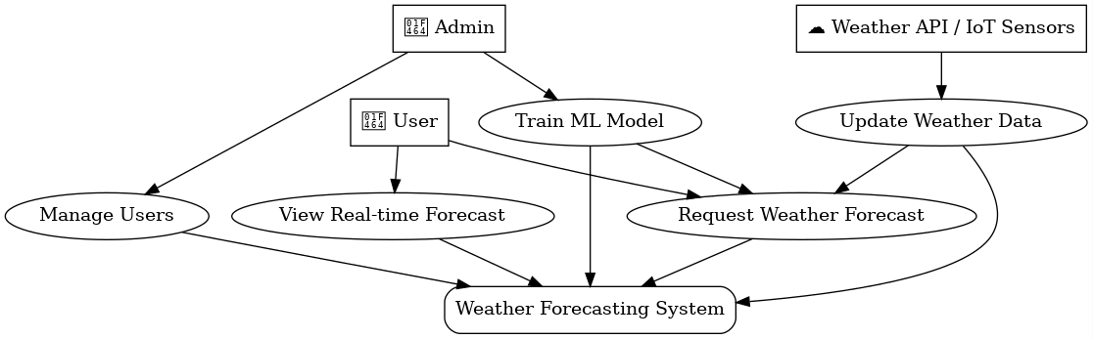

## 2. Class Diagram

Purpose: Defines the structure of the system, including the classes and their relations

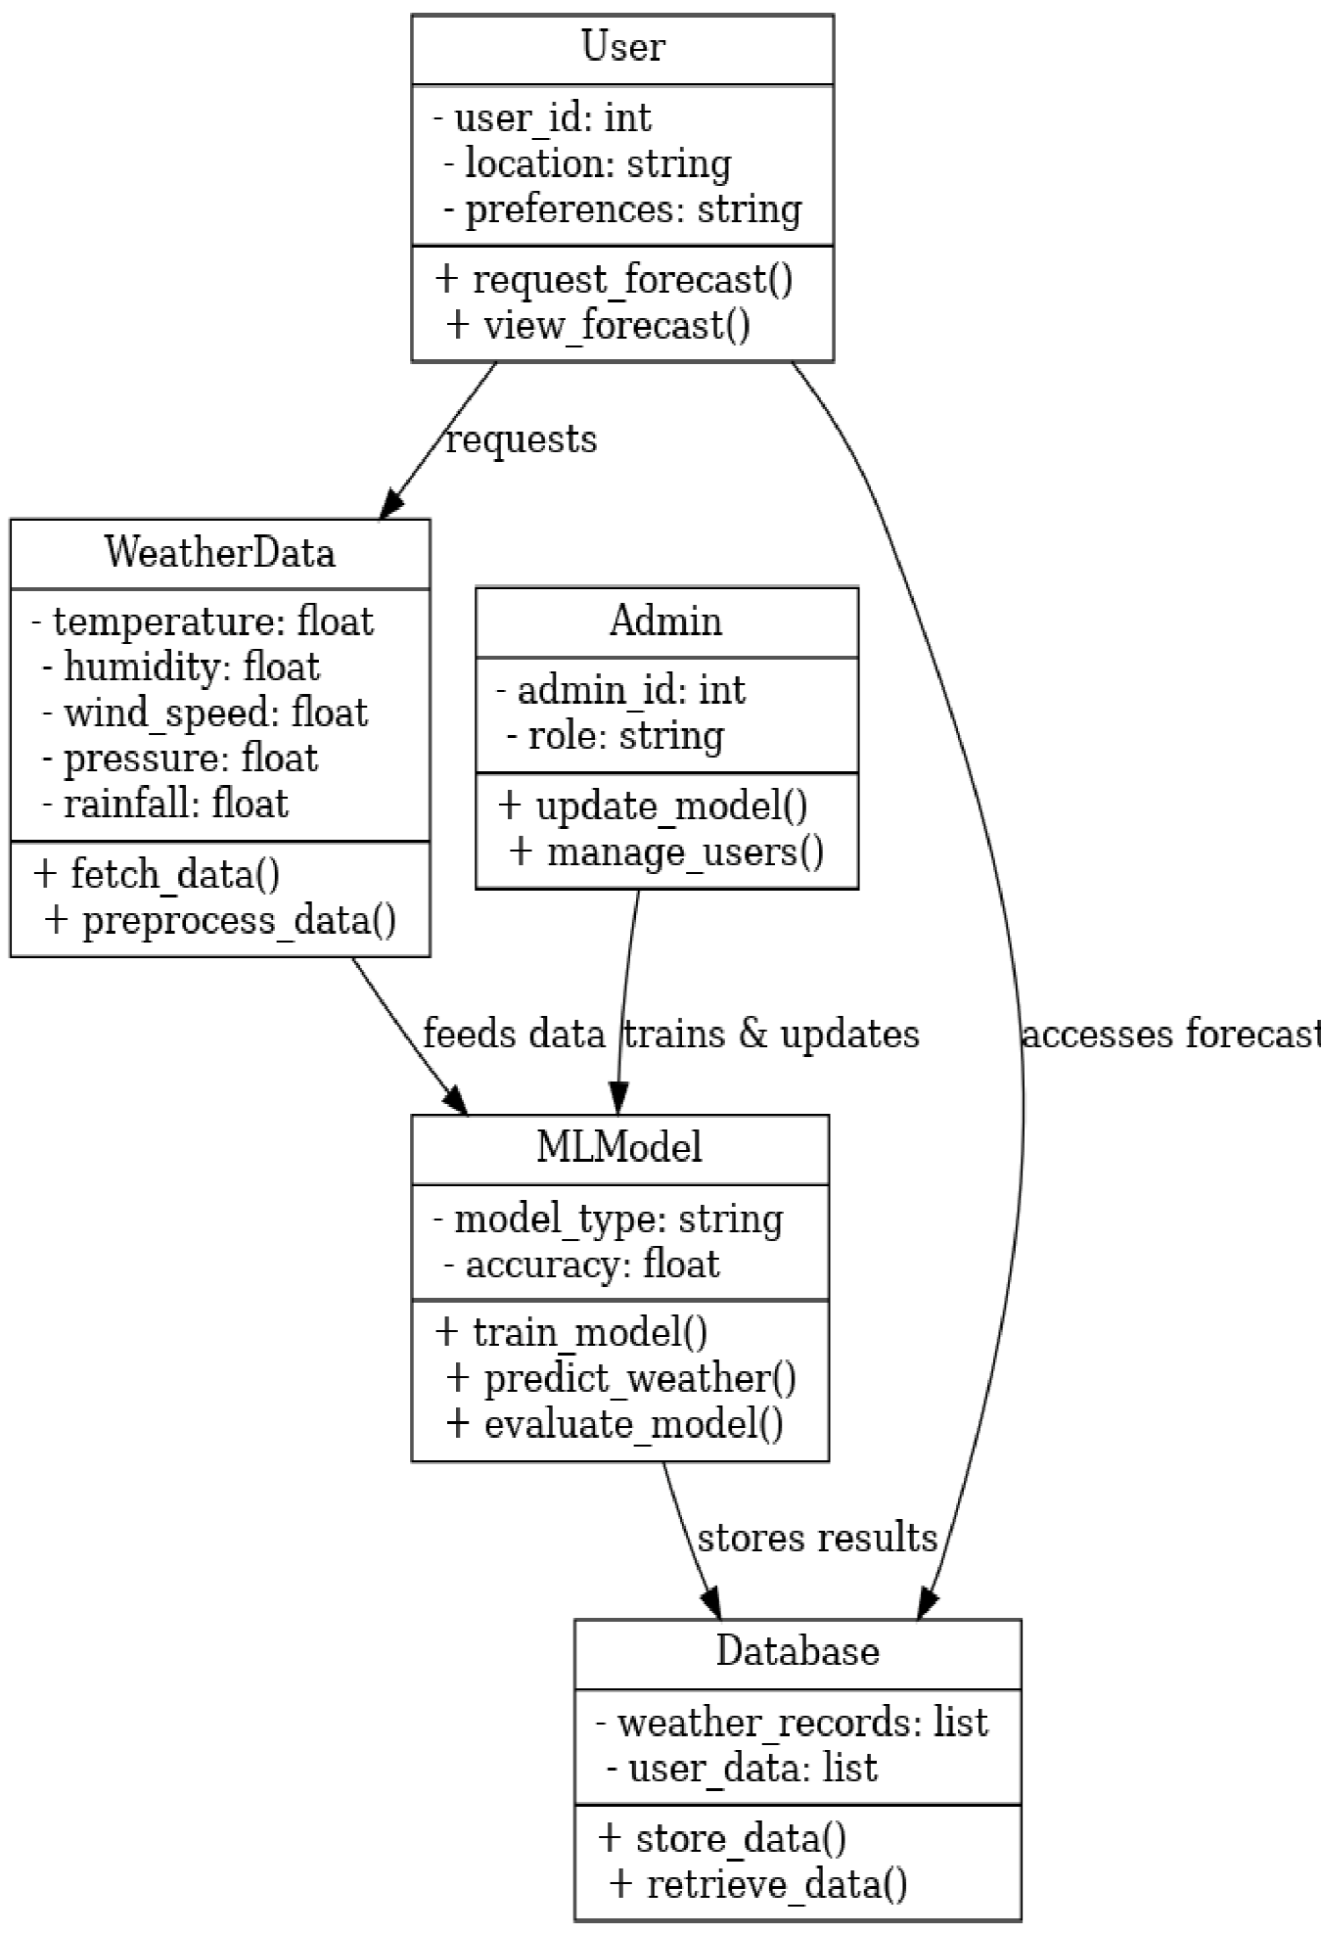

## 3.Sequence Diagram

Purpose: Shows the interaction flow between components in the system.

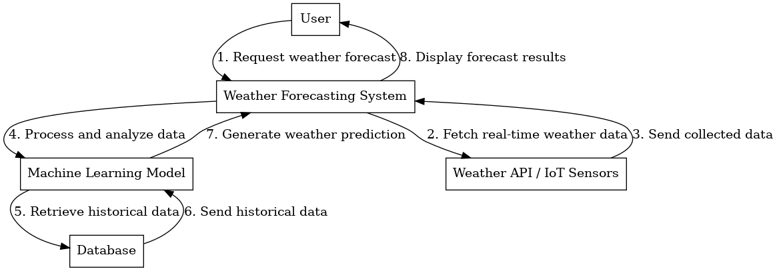

## 4. Activity Diagram

Purpose: Illustrates the workflow of weather forecasting.

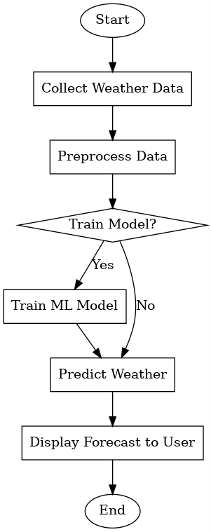

## 5. Deployment Diagram

Purpose: Represents the system’s deployment across different hardware components.

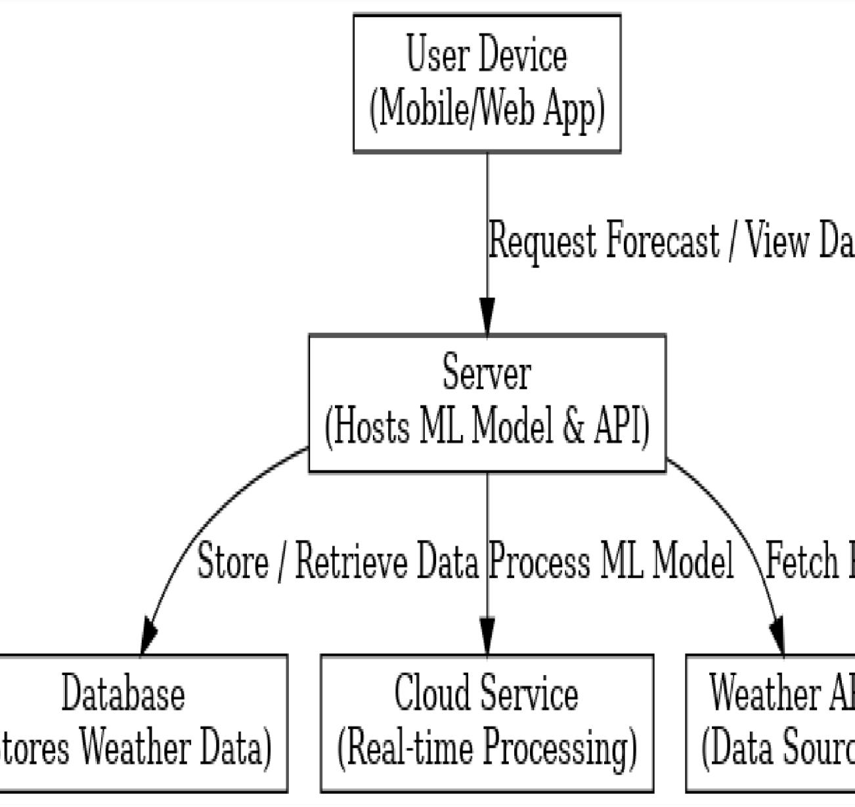

# 10.METHODS

Machine learning (ML) methods for weather forecasting can be broadly categorized into traditional ML models and deep learning approaches.

Here are some key methods:

1.Traditional Machine Learning Models These models use historical weather data and features like temperature, humidity, pressure, and wind speed.

Linear Regression: Predicts future weather conditions based on past trends (e.g., temperature tren.

Decision Trees: Uses a tree-like structure to make weather predictions based on multiple conditions.

Random Forest: An ensemble of decision trees that improves accuracy by reducing overfitting.

Support Vector Machines (SVM): Finds patterns in weather data for classification (e.g., storm vs. no storm).

K-Nearest Neighbors (KNN): Predicts weather based on similarity to past weather patterns.

2.Deep Learning Models Deep learning is used for more complex weather forecasting problems involving large data sets.

Artificial Neural Networks (ANNs): Can model nonlinear relationships in weather patterns.

Recurrent Neural Networks (RNNs) & Long Short-Term Memory (LSTM): Suitable for time -series forecasting (e.g., predicting hourly or daily temperatures).

Convolutional Neural Networks (CNNs): Used for processing satellite images and detecting weather patterns like hurricanes.

Transformers: Advanced models (like the Vision Transformer) that can analyze large-scale

3.Hybrid model LSTM + CNN: Used for combining temporal (time-series) and spatial (imagebased) weather data.

Ensemble Learning: Combines multiple ML models to improve accuracy.

4. Reinforcement Learning Used for adaptive weather forecasting, where the model learns by interacting with the environment (e.g., optimizing storm tracking).

5.Data Sources for ML Models

Satellite imagery (e.g., from NASA, NOAA)

Meteorological sensors (temperature, pressure, wind speed)

Historical weather data from agencies like IMD, ECMWF, or OpenWeatherMap

# 11. IMPLEMENTATION

Implementing weather forecasting using machine learning involves several steps, including data collection, preprocessing, model selection, training, and evaluation.

Below is a step-by-step guide with Python code.

1.Import Libraries import pandas as pd import numpy as np import matplotlib.pyplot as plt import seaborn as sns from sklearn.model_selection import train_test_split from sklearn.preprocessing import StandardScaler from sklearn.ensemble import RandomForestRegressor from sklearn.metrics import mean_absolute_error, mean_squared_error

1. Load and Preprocess Data You can use datasets like the NOAA Weather Data or Global Historical Climatology Network (GHCN).

Here, let's assume we have a CSV file weather_data.csv.

# Load dataset df = pd.read_csv('weather_data.csv')

# Display first few rows print(df.head())

# Check for missing values print(df.isnull().sum())

# Drop rows with missing values df.dropna(inplace=True)

1. Feature Selection Identify important features such as temperature, humidity, wind speed, pressure, etc.

# Selecting relevant features features = ['temperature', 'humidity', 'wind_speed', 'pressure'] target = 'next_day_temperature'

# Assuming we have this column X = df[features] y = df[target]

# Splitting data into training and testing sets X_train, X_test, y_train, y_test = train_test_split(X, y, test_size=0.2, random_state=42)

1. Feature Scaling scaler = StandardScaler()

X_train = scaler.fit_transform(X_train)

X_test = scaler.transform(X_test)

1. Model Selection & Training A Random Forest Regressor is a good starting point.

model = RandomForestRegressor(n_estimators=100, random_state=42)

model.fit(X_train, y_train)

1. Model Evaluation

# Predictions y_pred = model.predict(X_test) mean_squared_error(y_test, y_pred) rmse = np.sqrt(mse)

print(f"Mean Absolute Error (MAE): {mae}") print(f"Mean Squared Error (MSE): {mse}") print(f"Root Mean Squared Error (RMSE): {rmse}")

1. Visualization plt.figure(figsize=(10,5)) plt.plot(y_test.values, label='Actual', color='blue') plt.plot(y_pred, label='Predicted', color='red', linestyle='dashed') plt.legend() plt.xlabel("Sample Index") plt.ylabel("Temperature")

plt.title("Actual vs Predicted Temperature") plt.show()

1. Future Predictions Once trained, you can predict future weather conditions. # Example input: [temperature, humidity, wind_speed, pressure] future_data = np.array([[30, 65, 12, 1010]])

# Replace with real values

# Scale input data future_data = scaler.transform(future_data) # Predict temperature future_temp = model.predict(future_data) print(f"Predicted Temperature: {future_temp[0]}°C")

Next Steps

Try different models like XGBoost, LSTMs (for time series forecasting), or CNNs.

Use larger datasets with more parameters.

Deploy as a Flask API to integrate with a web app

# 12.RESULTS

Weather forecasting using machine learning (ML) has become a powerful tool that complements traditional physics-based models.

Here's a summary of results and effectiveness observed in weather forecasting using ML:

## 1.Accuracy Improvement

•Short-term forecasts (0–6 hours): ML models often outperform traditional methods by capturing local patterns from large datasets.

•Medium-term (1–7 days): ML can match or slightly improve accuracy when combined with physics-based models.

Example:

• Google's DeepMind developed GraphCast, which outperforms ECMWF’s HRES model in many key global metrics for 5–10 day forecasts.

## Comparison: ML vs. Traditional Numerical

Weather Prediction (NWP) Feature Speed Data requirement Machine Learning Traditional NWP Much faster (seconds/minutes) Slower (requires supercomputers) Requires large historical datasets Requires physics and initial conditions Accuracy (short-term) Often better Accuracy (longer-term) Still catching up Interpretability Often a black box Good Generally better More interpretable Performance Metrics in Research

* RMSE (Root Mean Square Error) and MAE (Mean Absolute Error) often show 10–30% improvements with ML models in specific scenarios.
* ML methods like Random Forests, Gradient Boosting, LSTMs, ConvLSTMs, Transformers are used. Use Cases

1.Rainfall prediction (especially for specific locations)

2.Temperature forecasting

1. Cyclone/hurricane path prediction
2. Nowcasting (very short-term forecasts, like radar-based rain prediction)
3. Solar and wind power forecasting for renewable energy

# Tools and Models Example

•GraphCast (DeepMind)

•FourCastNet (NVIDIA)

* NowcastNet
* WeatherBench: a benchmark dataset to compare ML weather

# 13.CONCLUSION

Weather forecasting using machine learning has proven to be an effective and efficient method for predicting weather conditions based on historical data.

By leveraging techniques like regression models, decision trees, and deep learning, machine learning algorithms can identify patterns and relationships in weather parameters such as temperature, humidity, wind speed, and pressure.

Key takeaways from this project include:

1. Improved Accuracy: Machine learning models, especially ensemble methods like Random Forest and deep learning approaches like LSTMs, can provide better predictions compared to traditional statistical models.
2. Automation & Scalability: Once trained, ML models can process vast amounts of real- time data and make continuous predictions without manual intervention.
3. Challenges: The accuracy of forecasts depends on the quality and quantity of data, feature selection, and hyperparameter tuning. Additionally, external factors like climate change can introduce uncertainties.
4. Future Scope: Integrating real-time weather data APIs, using more advanced models (e.g., deep learning with time series forecasting), and deploying predictive systems in applications like disaster management can enhance the impact of ML-based weather forecasting. Overall, machine learning provides a promising approach to weather forecasting, but continuous improvements in data collection and model optimization are necessary to achieve higher accuracy and reliability.

# 14.REFERENCE

Here are some references that can help you understand weather forecasting using machine learning in more detail:

## Research Papers & Articles

1.Sharma, A., Mehndiratta, P., & Choudhury, T. (2021).

"Machine Learning Techniques for Weather Forecasting: A Review." International Journal of Advances in Science and Technology, 29(3), 56-72. [Available on Google Scholar]

2.Rasp, S., Pritchard, M. S., & Gentine, P. (2018). "Deep learning to represent subgrid processes in climate models." Proceedings of the National Academy of Sciences, 115(39), 9684-9689. [DOI: 10.1073/pnas.1810286115]

3.Ahmad, S., & Lin, J. (2020). "Weather Forecasting Using Machine Learning Algorithms."

International Journal of Computer Applications, 177(15), 30-35. [Available at ResearchGate]

## Books

1.“Machine Learning for Time-Series Forecasting with Python” – Francesca Lazzeri Covers time-series forecasting techniques, including weather prediction.

2.“Data Science for Weather and Climate” – Thomas H. Wickham Discusses how data science and ML techniques apply to meteorological forecasting.

## Online Resources & Tutorials

1.Google AI Blog – Articles on AI applications in weather forecasting https://ai.googleblog.com/

2.Kaggle Datasets & Notebooks Weather forecasting ML projects: https://www.kaggle.com/datasets

3. GitHub Repositories ML-based weather prediction projects: https://github.com/topics/weather-forecast